Project Planning Template
Product Backlog, Sprint Planning, Stories & Story Points
Date | 26 September 2026
Team ID | SWTID-2026-1610
Project Name | AI Study Buddy
Maximum Marks | 5 Marks

Product Backlog, Sprint Schedule and Estimation
Sprint | Functional Requirement (Epic) | User Story Number | User Story / Task | Story Points | Priority | Team Members
Sprint-1 | Registration | USN-1 | As a student, I can register for the application by providing my required account details. | 2 | High | Akshaya, Reshma
Sprint-1 | Login & Authentication | USN-2 | As a student, I can log into the application using my registered credentials. | 2 | High | Akshaya, Reshma
Sprint-1 | Authentication | USN-3 | As a student, I can access protected features using a valid authentication token. | 2 | High | Reshma, Kiruthiga
Sprint-1 | Study Material Upload | USN-4 | As a student, I can upload my study material in PDF format. | 3 | High | Reshma, Sivaranjani
Sprint-1 | Material Processing | USN-5 | As a student, I can upload study material and have its text extracted by the system. | 3 | High | Reshma, Sivaranjani
Sprint-2 | AI Summary | USN-6 | As a student, I can generate a summary from my uploaded study material. | 3 | High | Reshma, Kiruthiga
Sprint-2 | AI Flashcards | USN-7 | As a student, I can generate flashcards from my study material for revision. | 3 | High | Kiruthiga, Reshma
Sprint-2 | AI Quiz | USN-8 | As a student, I can generate a quiz from my uploaded study material. | 3 | High | Akshaya, Sivaranjani
Sprint-2 | Personalized Study Plan | USN-9 | As a student, I can generate a personalized study plan based on my goal, available hours and number of days. | 3 | High | Akshaya, Reshma
Total Story Points
Sprint-1: 12 Story Points
Sprint-2: 12 Story Points
Total: 24 Story Points

Project Tracker, Velocity & Burndown Chart
Since this is a documentation/planning template, we can use the planned sprint schedule below.
Sprint | Total Story Points | Duration | Sprint Start Date | Sprint End Date (Planned) | Story Points Completed | Sprint Release Date (Actual)
Sprint-1 | 12 | 6 Days | 17 Feb 2025 | 22 Feb 2025 | 12 | 22 Feb 2025
Sprint-2 | 12 | 6 Days | 24 Feb 2025 | 01 Mar 2025 | 12 | 01 Mar 2025

Velocity
Velocity represents the number of story points completed by the team during a sprint.
Sprint-1
Total Story Points = 12
Duration = 6 days
Average Velocity per Day = 12 ÷ 6 = 2 Story Points/Day
Sprint-2
Total Story Points = 12
Duration = 6 days
Average Velocity per Day = 12 ÷ 6 = 2 Story Points/Day
Team Average Velocity
Average Velocity = (12 + 12) ÷ (6 + 6)
= 24 ÷ 12
= 2 Story Points per Day
Therefore, the planned team velocity is:
2 Story Points per Day

Burndown Chart
The burndown chart represents the amount of work remaining during each sprint.
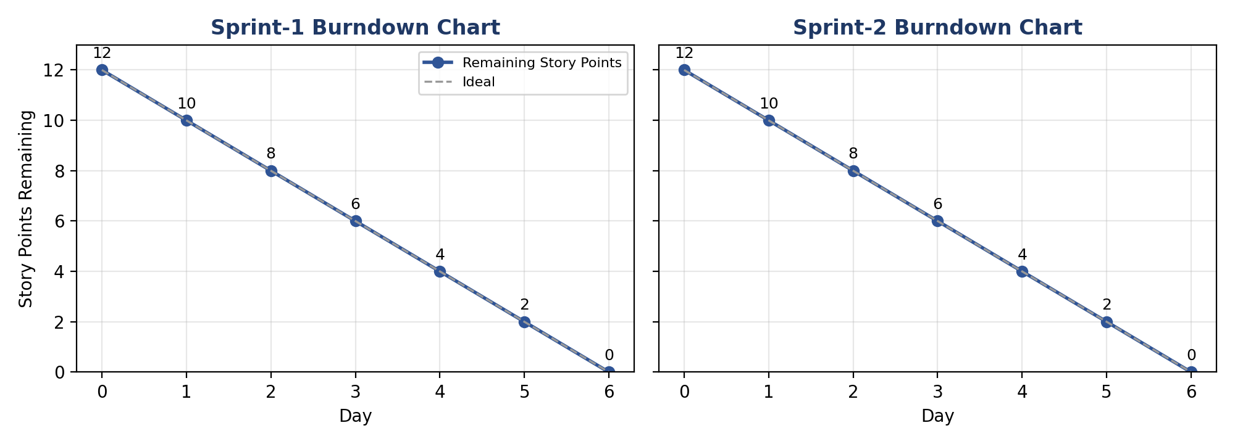
For Sprint-1, the team starts with 12 story points. | For Sprint-2, the team starts with 12 story points.
  Day | Story Points Remaining
  Day 1 | 10
  Day 2 | 8
  Day 3 | 6
  Day 4 | 4
  Day 5 | 2
  Day 6 | 0
  Day | Story Points Remaining
  Day 1 | 10
  Day 2 | 8
  Day 3 | 6
  Day 4 | 4
  Day 5 | 2
  Day 6 | 0

Sprint Planning Summary
The project is divided into two sprints. Sprint-1 focuses on user registration, login, authentication, PDF upload, and material processing. Sprint-2 focuses on AI-powered summary, flashcards, quiz, and personalized study plan generation.
The total planned work is 24 story points, with a planned average velocity of 2 story points per day.

